**CREATE AND CONFIGURE IBM CLOUD SERVICES**

Create NODE-RED Service

# Team ID : PNT2022TMID05693

# Project Name Project - Smart Waste Management System For Metropolitan City

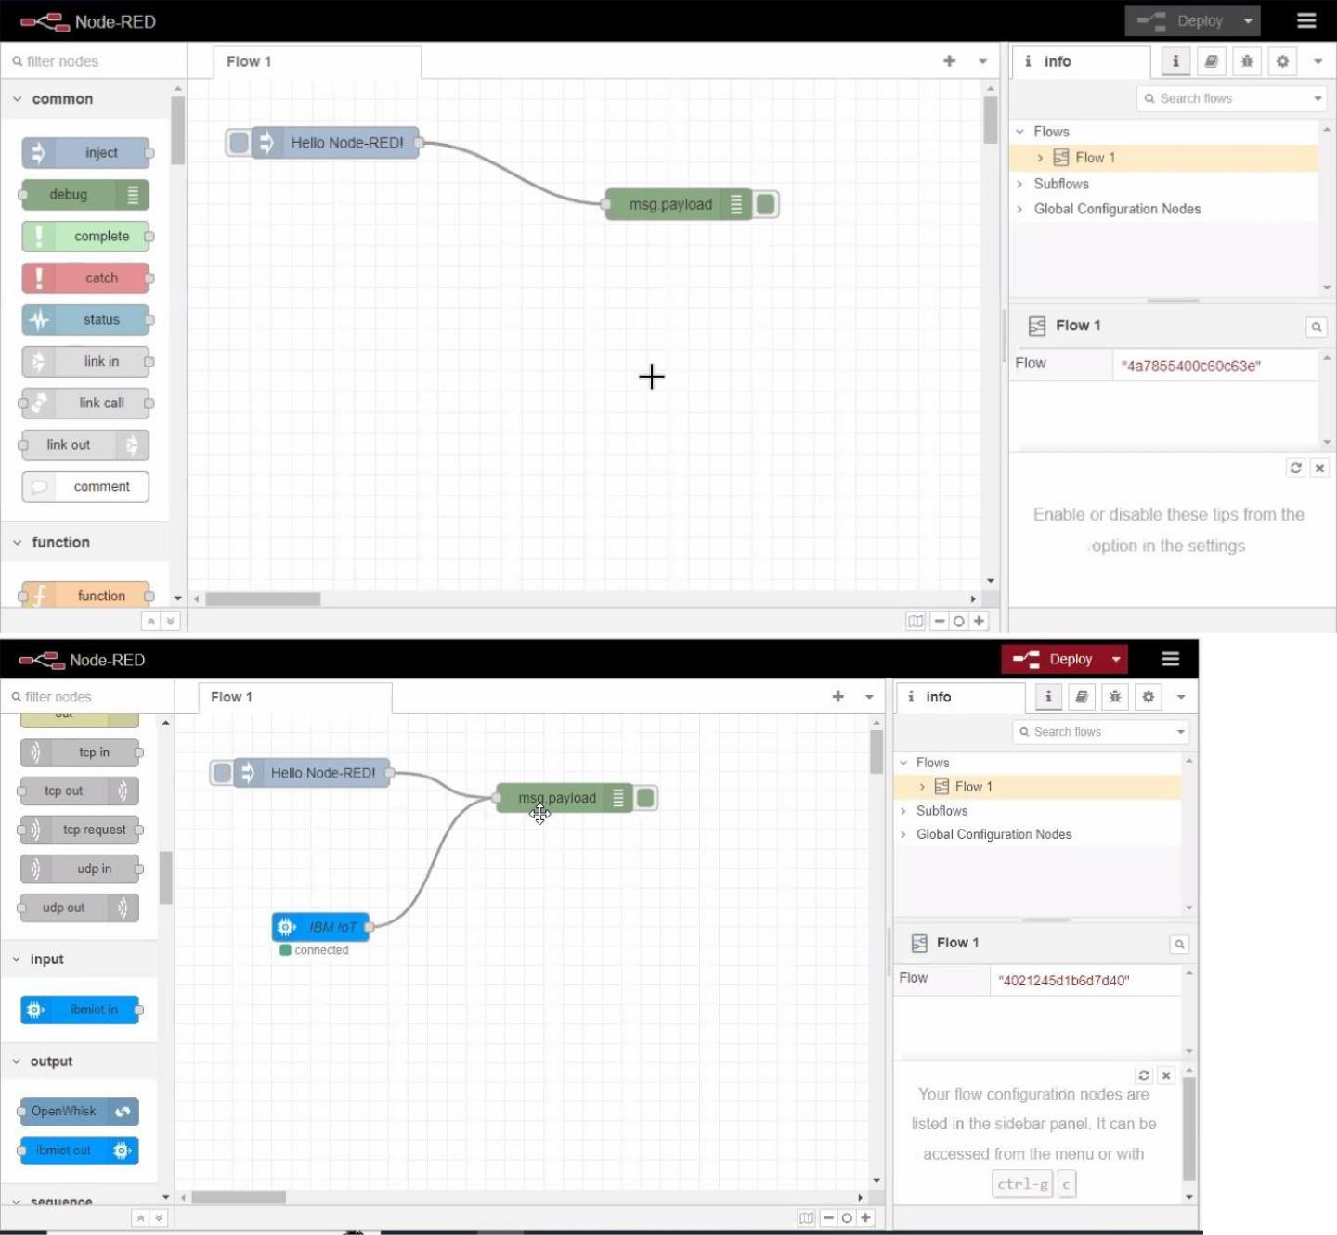

 

A Nat secure | node-red-iJzhqs-2022-10-08.au-syd.myb1uemix.net/red/*flow/4a7855400c60c63e 

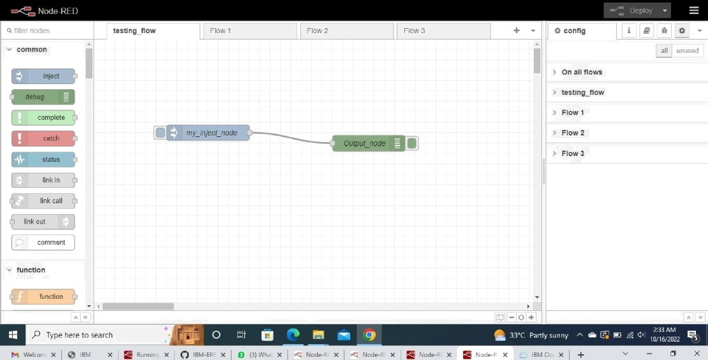M & 6e @ Maps New Raspberry Pi P.. e Colorful Clean S Pa* W IBM Watson 4oT Pla.

k 4 C & Nat secure | node-red-uzhqs-2022-10-08.au-syd.myb1uem\x nef/'red/how/4a7855400c60o63e 

P•g be @ Maps New Rasp b erry Pi P.. e Colorful Clean S Pol W- IBM Wafson JoT Pla.

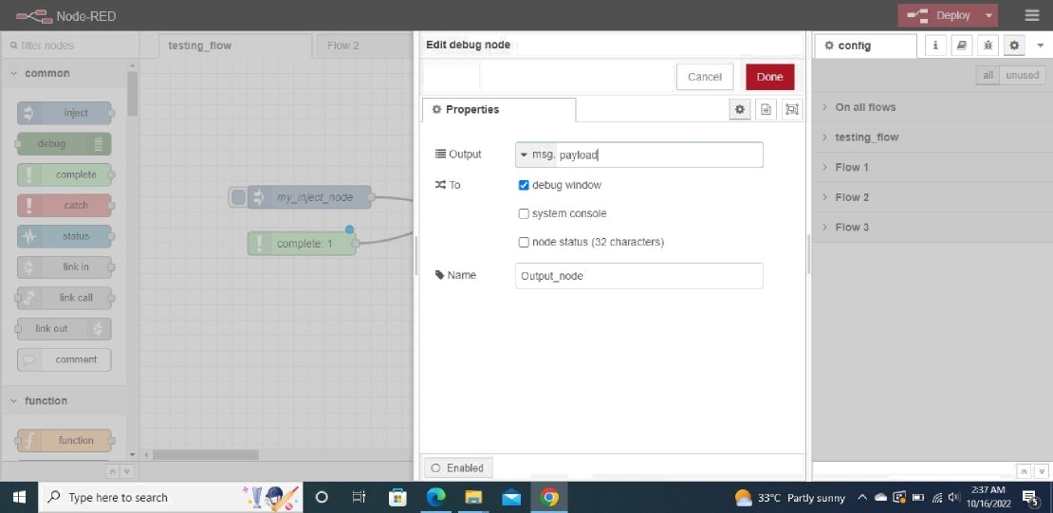

Delete